***DATA BASE LAB-3***

**Q 1:** SELECT ename, job, deptno FROM emp WHERE job= 'CLERK';

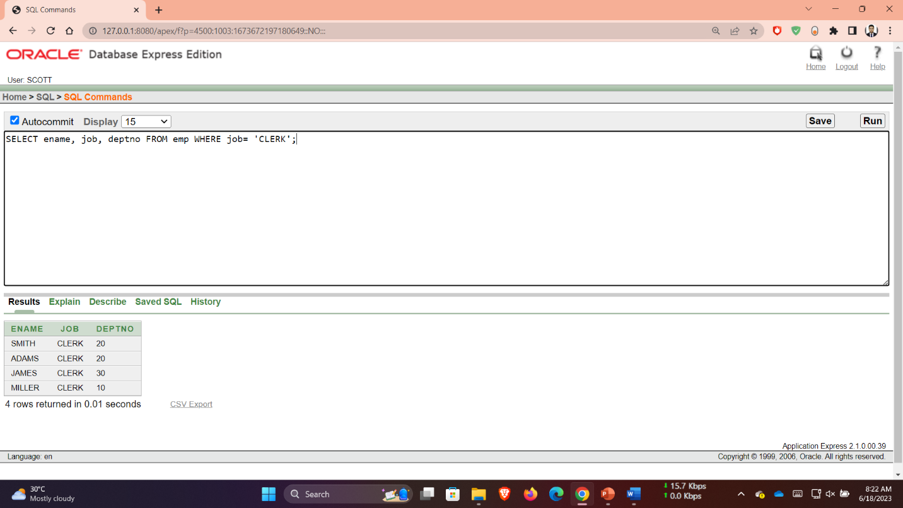

**Q 02**: SELECT ename, job, deptno FROM emp WHERE ename= 'JAMES';

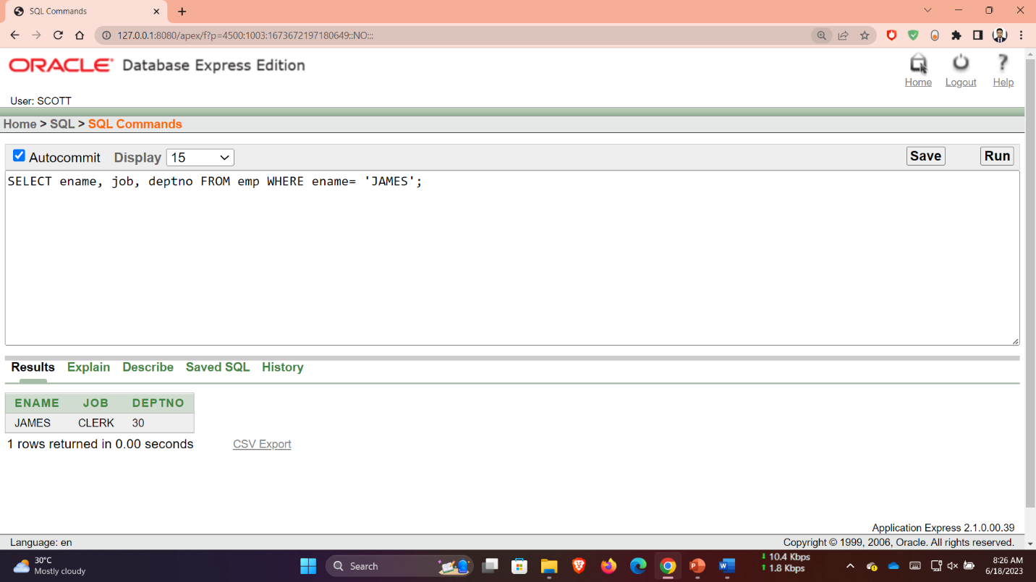

**Q 03**: SELECT ename, sal, comm FROM emp WHERE sal<=comm;

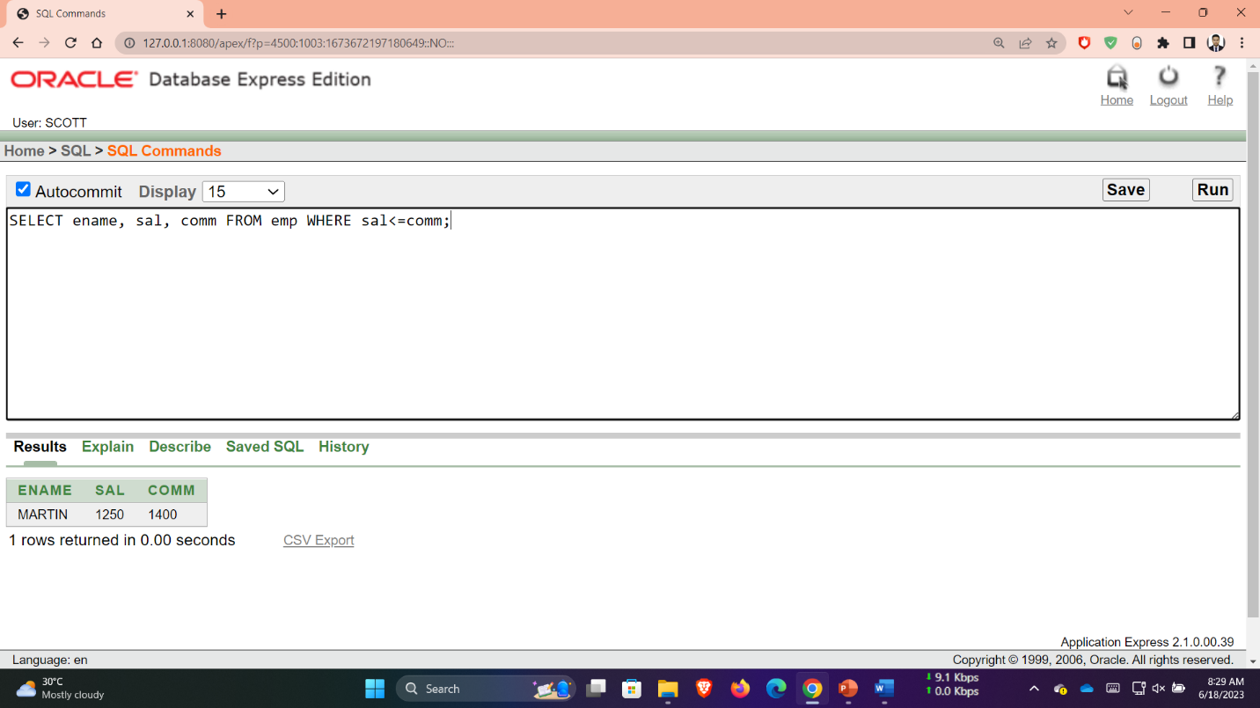

**Q 04**: SELECT ename, sal FROM emp WHERE sal BETWEEN 1000 AND 1500;

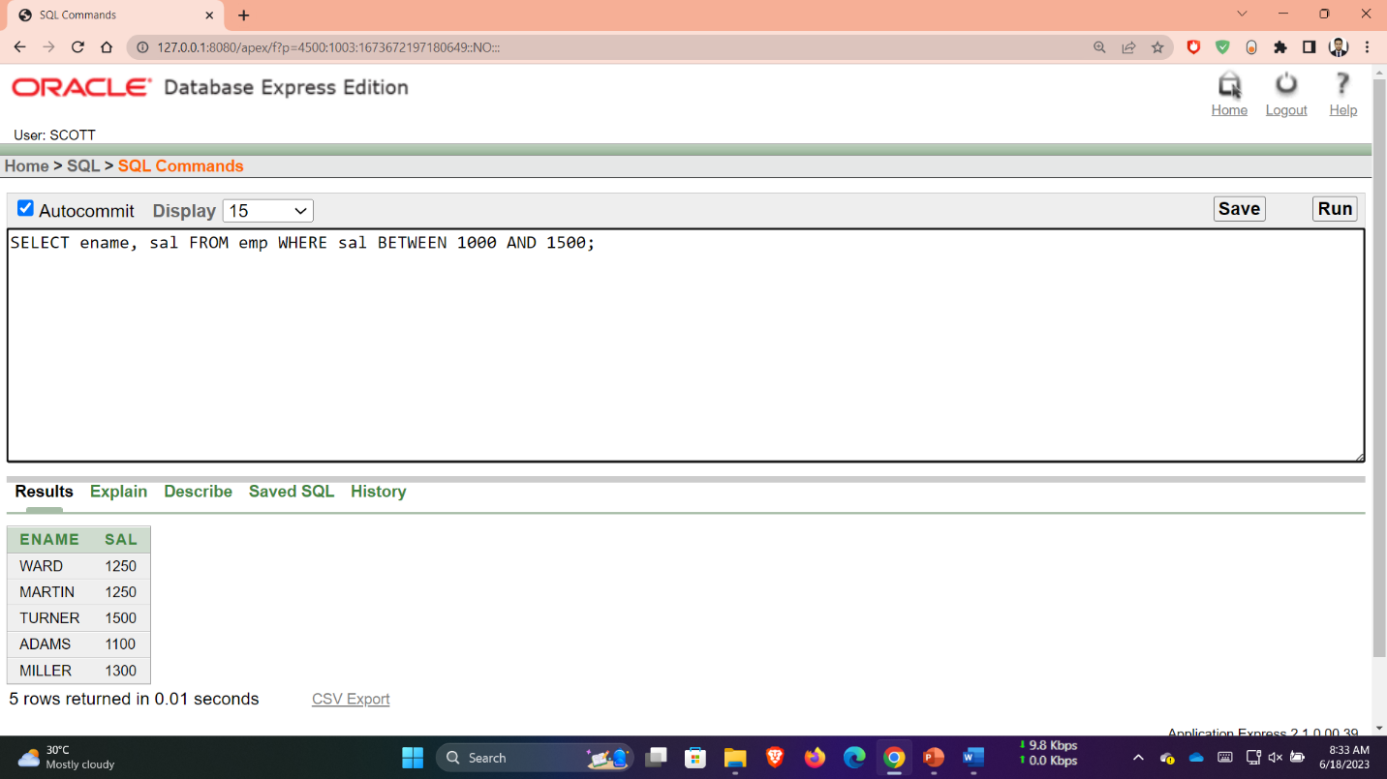

**Q 5**: SELECT empno, ename, sal, mgr FROM emp WHERE mgr IN (7902, 7566, 7788);

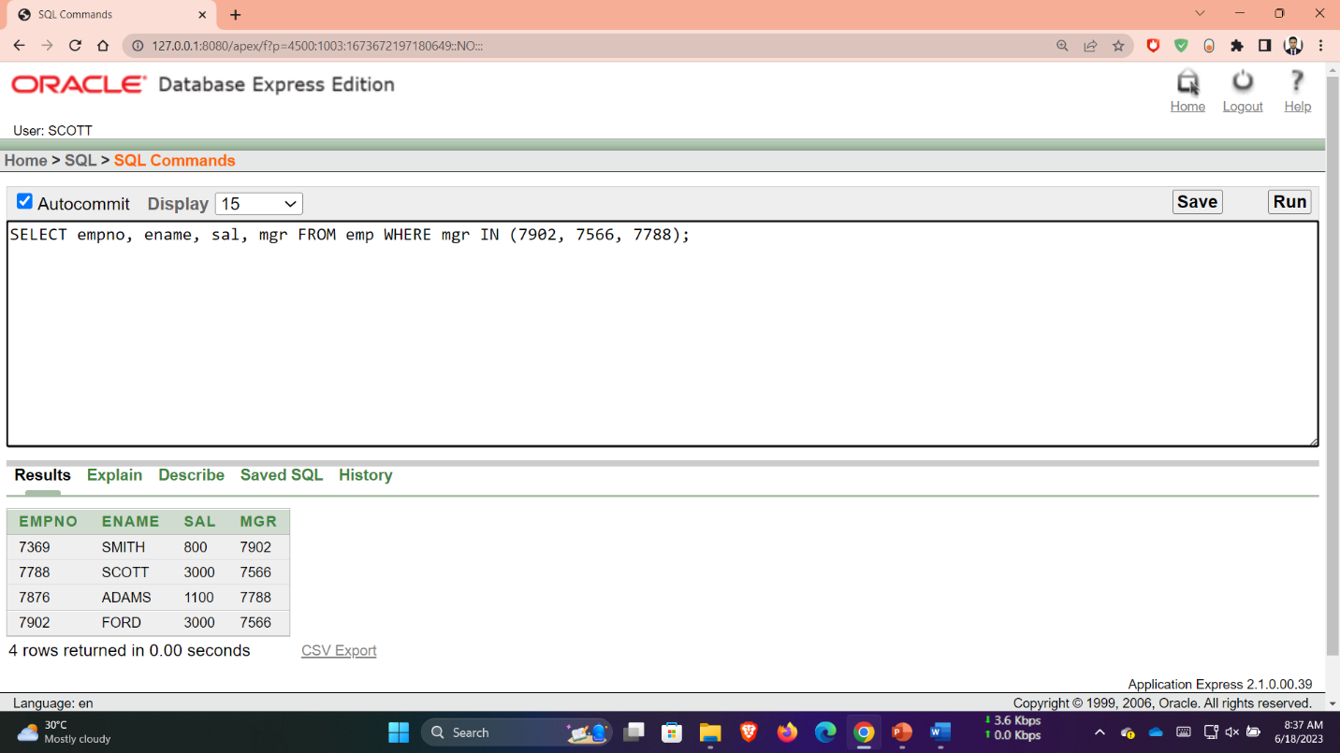

**Q 6**: SELECT ename FROM emp WHERE ename LIKE '_A%';

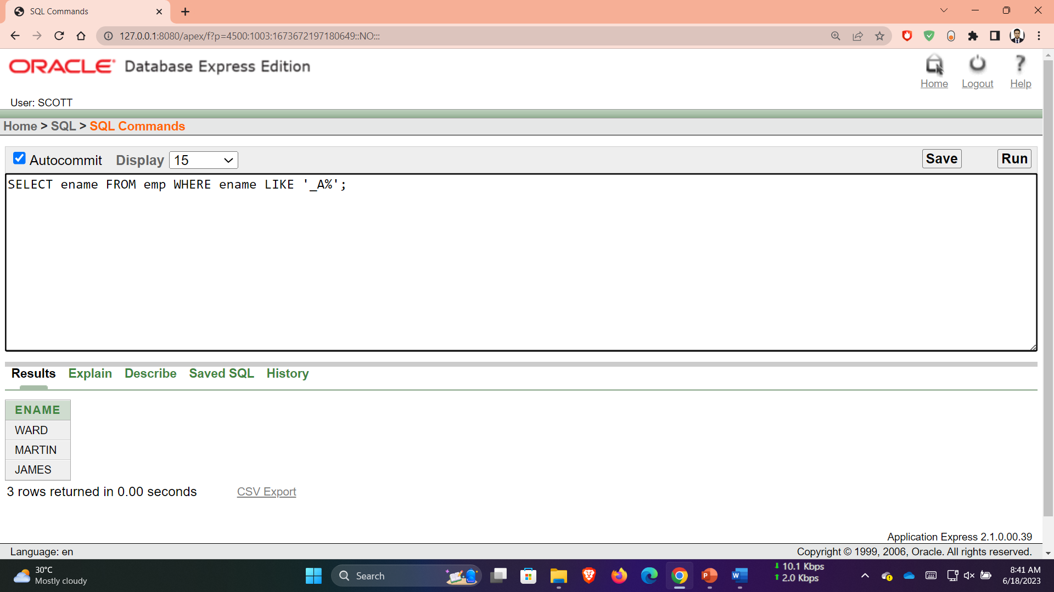

**Q 7**: SELECT ename, mgr FROM emp WHERE mgr IS NULL;

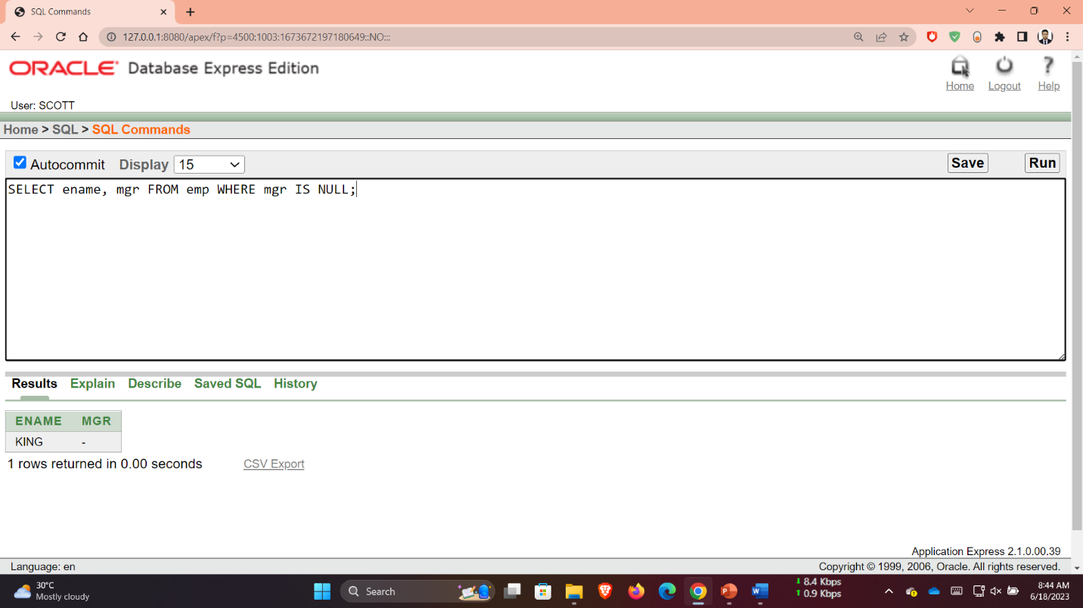

**Q 8**: SELECT empno, ename, job, sal FROM emp WHERE sal>=1100 AND job= 'CLERK';

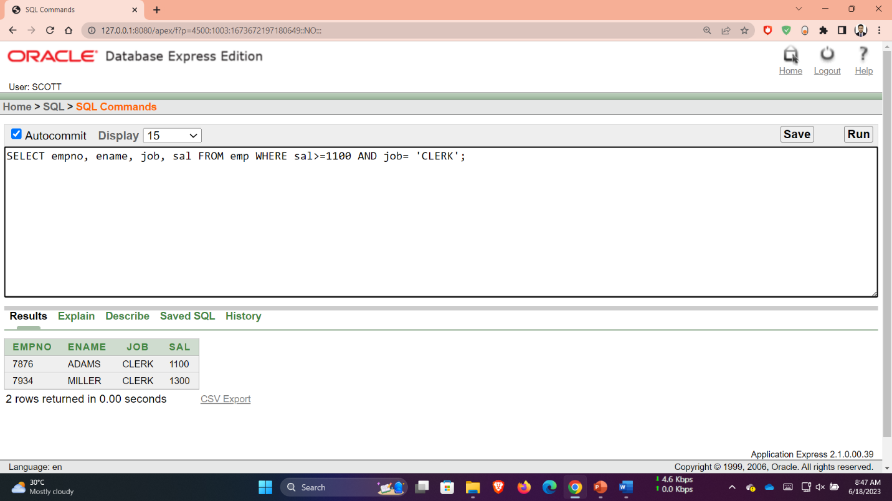

**Q 9**: SELECT empno, ename, job, sal FROM emp WHERE sal>=1100 OR job= 'CLERK';

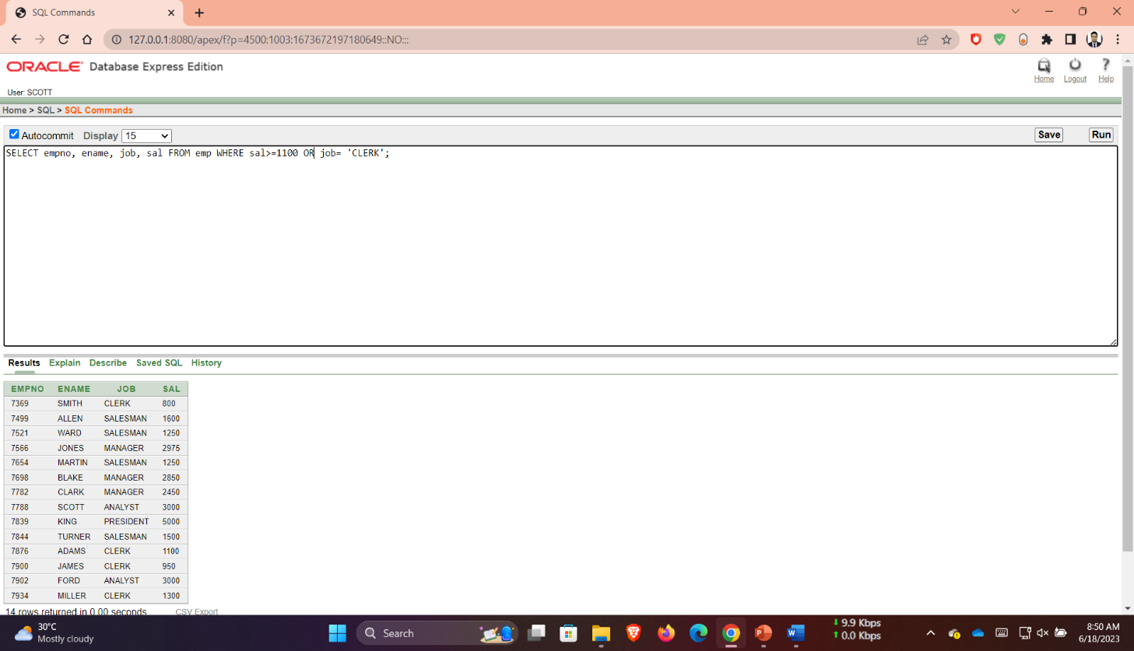

**Q 10**: SELECT ename, job FROM emp WHERE job NOT in ('CLERK', 'MANAGER', 'ANALYST');

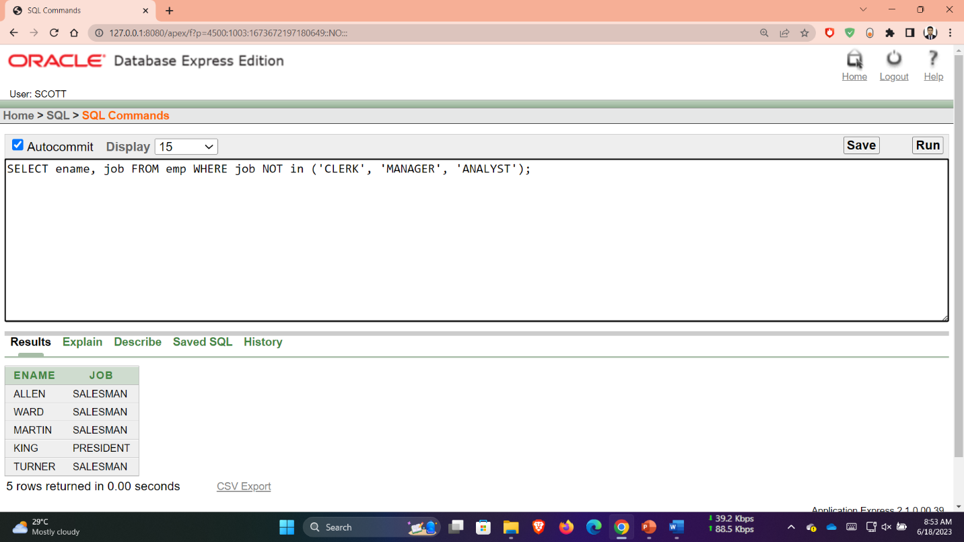

**Q 11**: SELECT ename, job, sal FROM emp WHERE (job='SALESMAN' OR job='PRESIDENT') AND sal>1500;

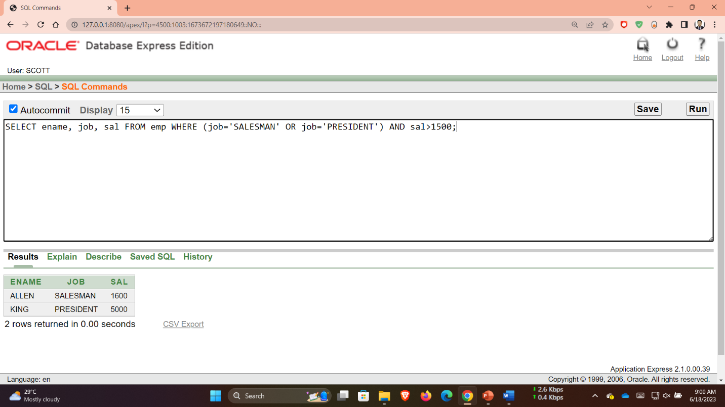

**Q 12**: SELECT ename, job, sal FROM emp WHERE job='SALESMAN' OR job='PRESIDENT' AND sal>1500;

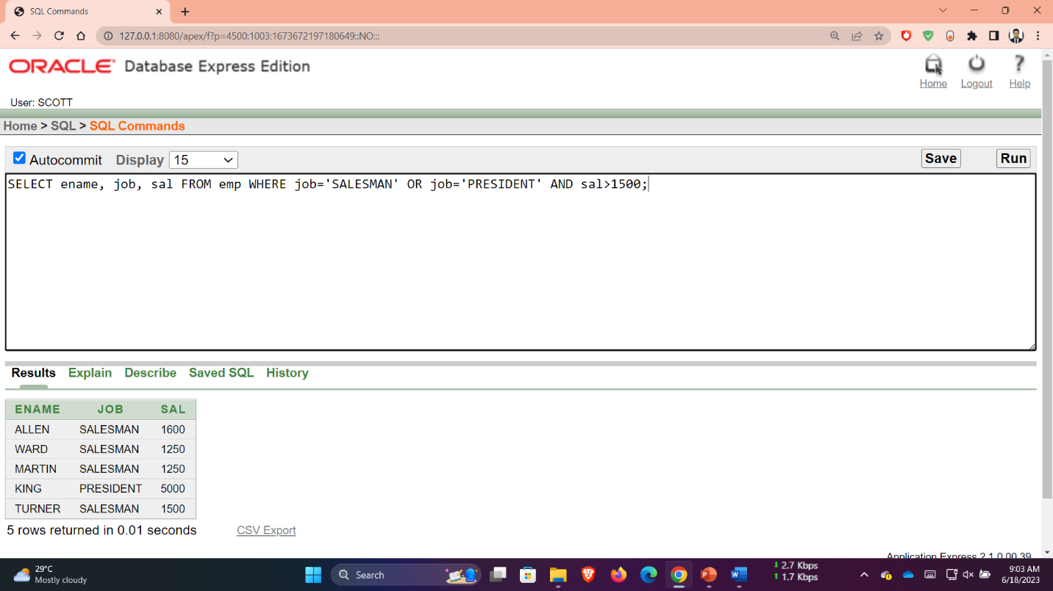

**Q 13**: SELECT ename, job, deptno, hiredate FROM emp ORDER BY hiredate;

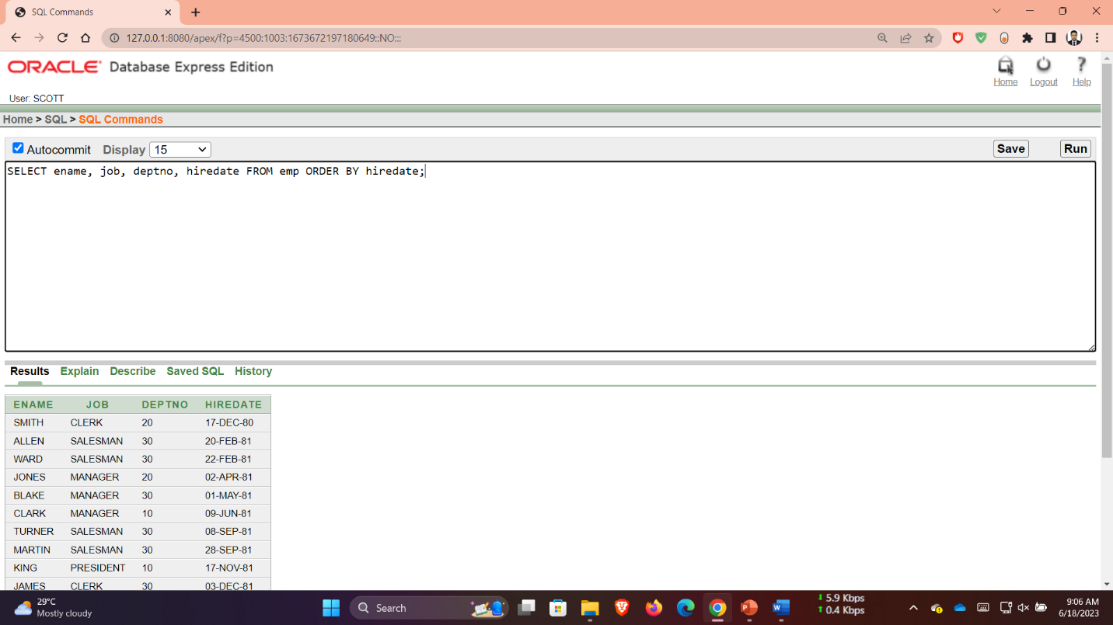

**Q 14**: SELECT ename, job, deptno, hiredate FROM emp ORDER BY hiredate DESC;

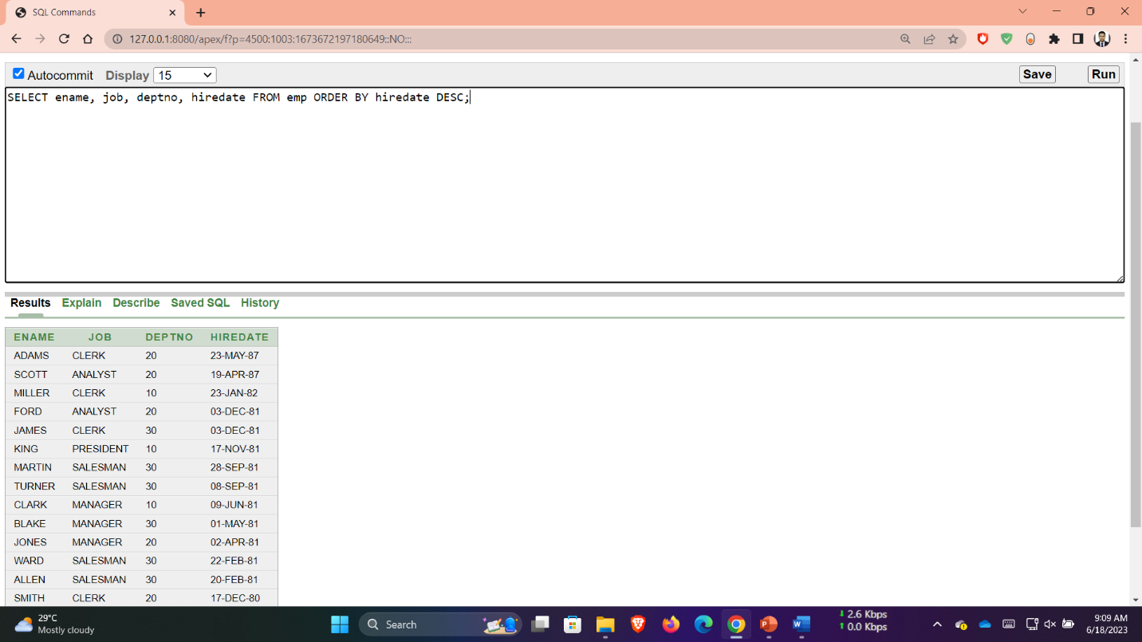

**Q 15**: SELECT empno, ename, sal*12 annsal FROM emp ORDER BY annsal;

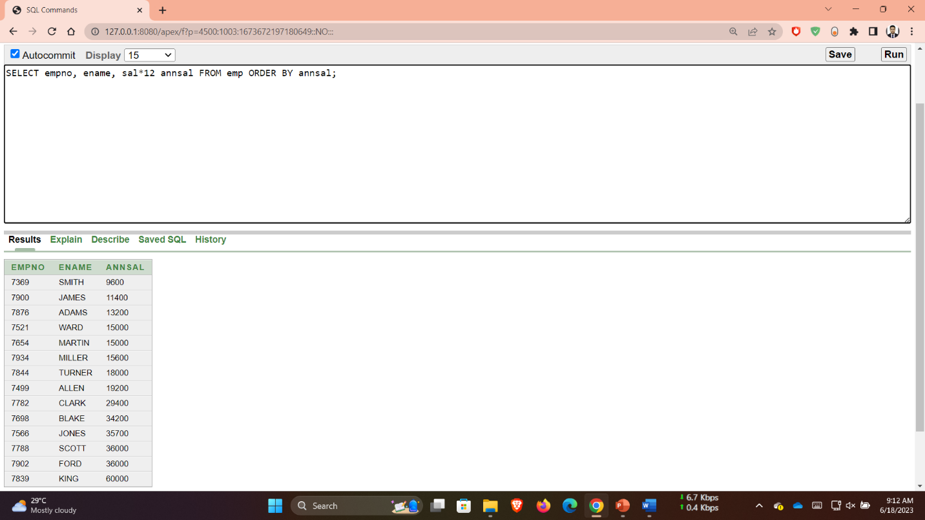

**Q 16**: SELECT ename, deptno, sal FROM emp ORDER BY deptno, sal DESC;

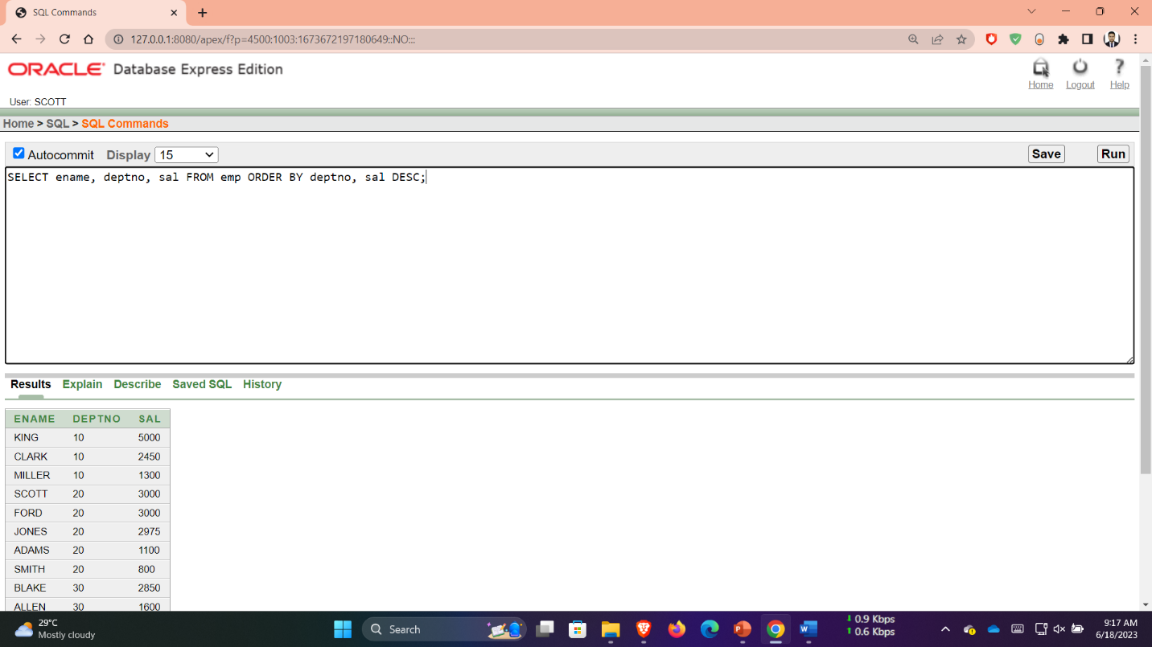

**Q 1**: SELECT empno, ename, deptno, FROM emp WHERE ename = 'blank';

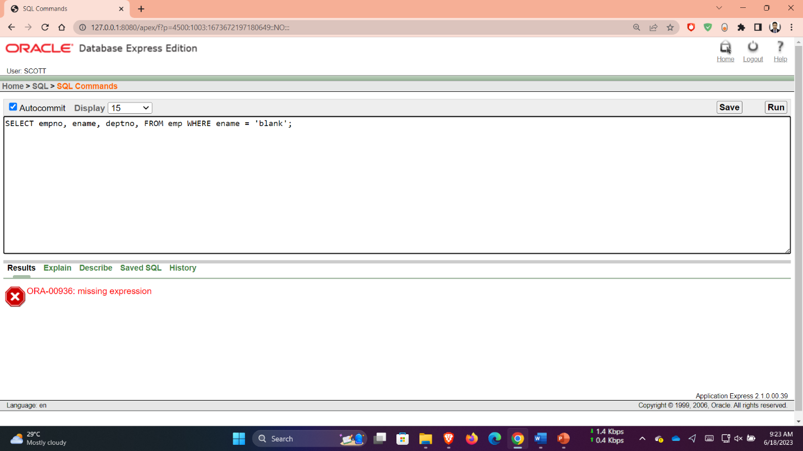

**Q 2**: SELECT empno, ename, deptno FROM emp WHERE LOWER(ename) = 'blake';

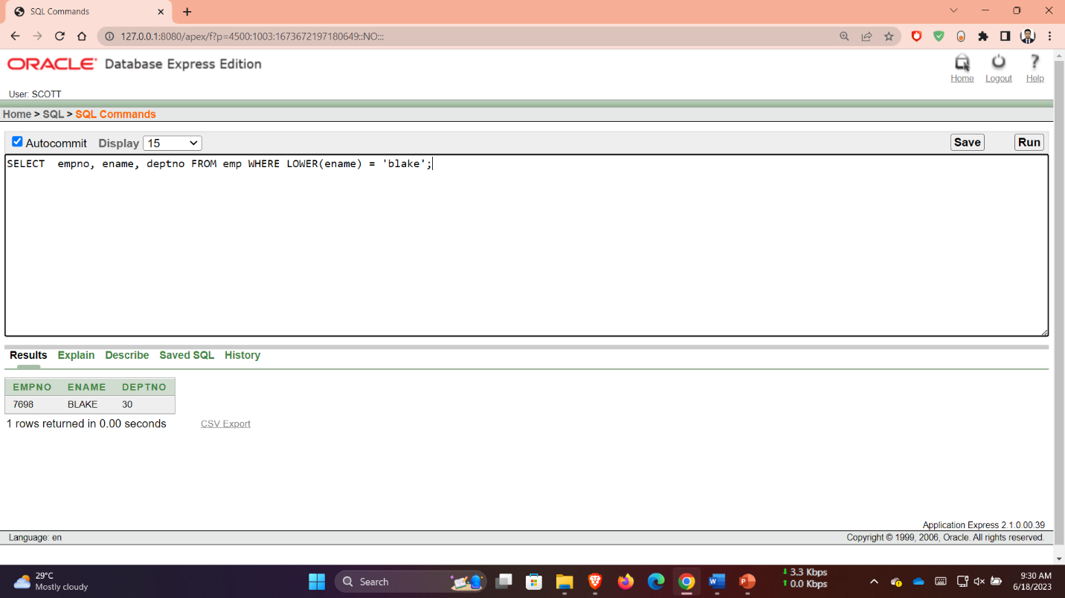

**Q 3**: SELECT ename, CONCAT (ename, job), LENGTH(ename), INSTR(ename, 'A') FROM emp WHERE SUBSTR(job,1,5) = 'SALES';

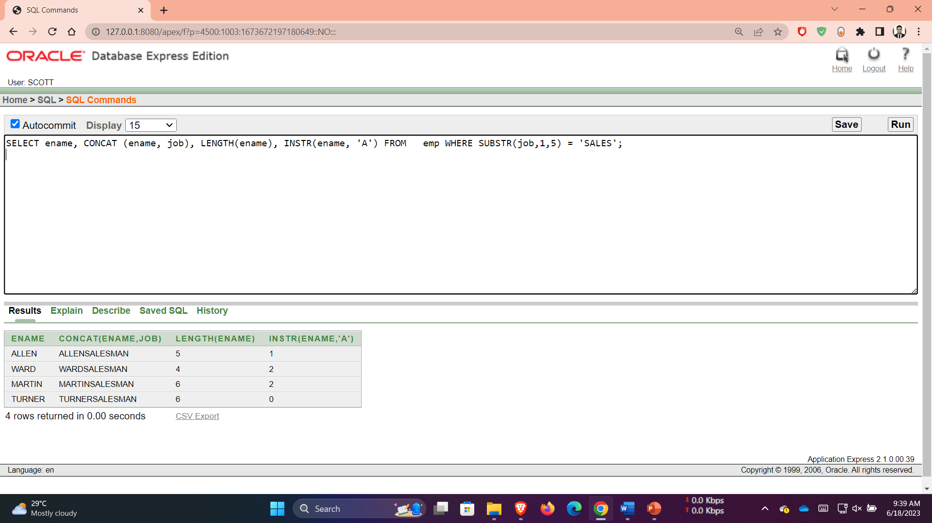

**Q 4**: SELECT ROUND(45.923,2), ROUND(45.923,0), ROUND(45.923,-1) FROM DUAL;

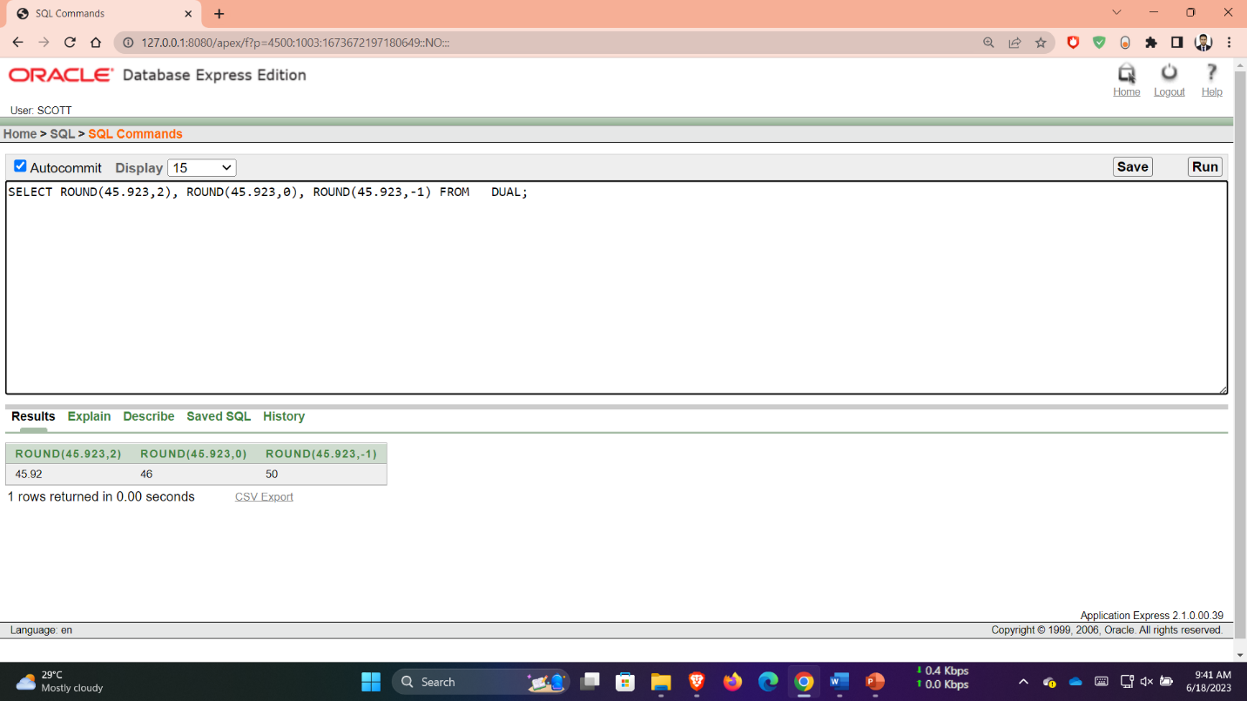

**Q 5**: SELECT TRUNC(45.923,2), TRUNC(45.923), TRUNC(45.923,-1) FROM DUAL;

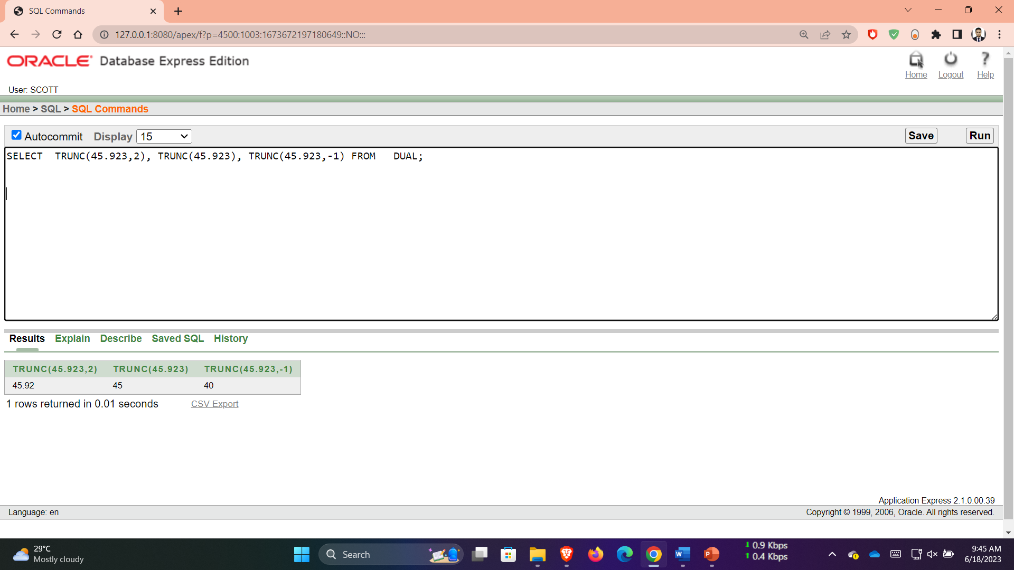

**Q 6**: SELECT ename, sal, comm, MOD(sal, comm) FROM emp WHERE job = 'SALESMAN';

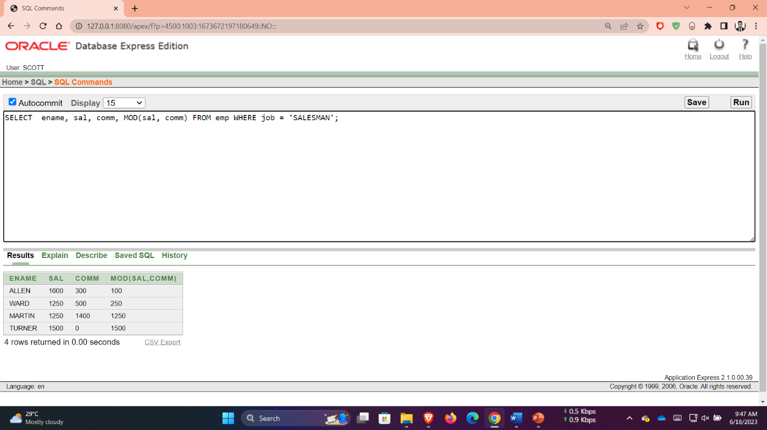

**Q 7**: SELECT ename, (SYSDATE-hiredate)/7 WEEKS FROM emp WHERE deptno = 10;

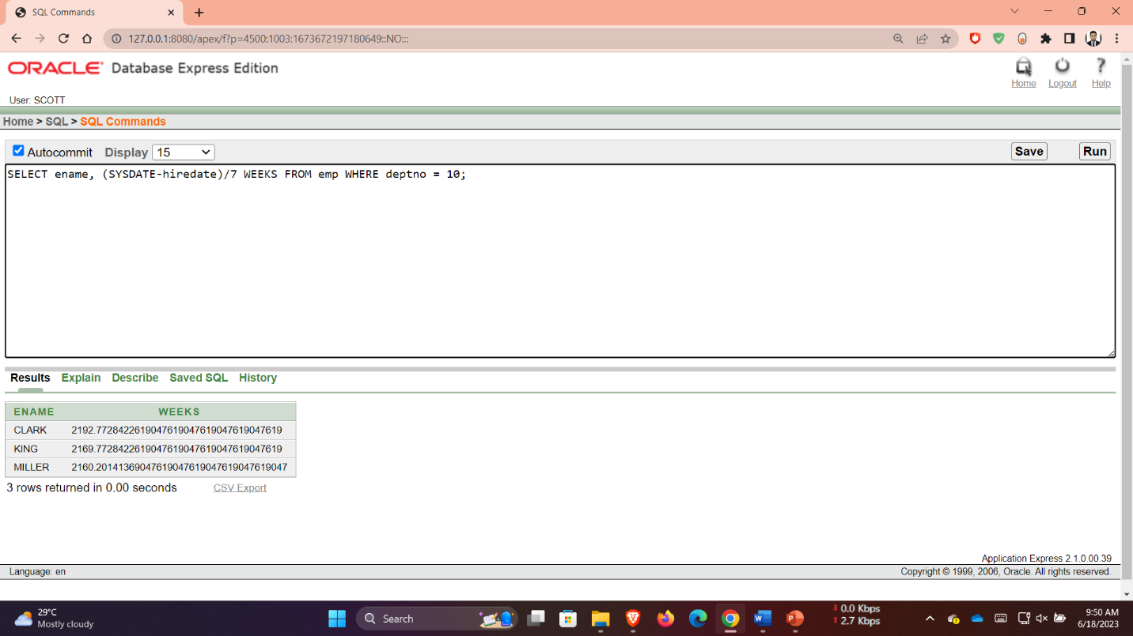

**Q 8**: SELECT ename, TO_CHAR(hiredate, 'fmDD Month YYYY') HIREDATE FROM emp;

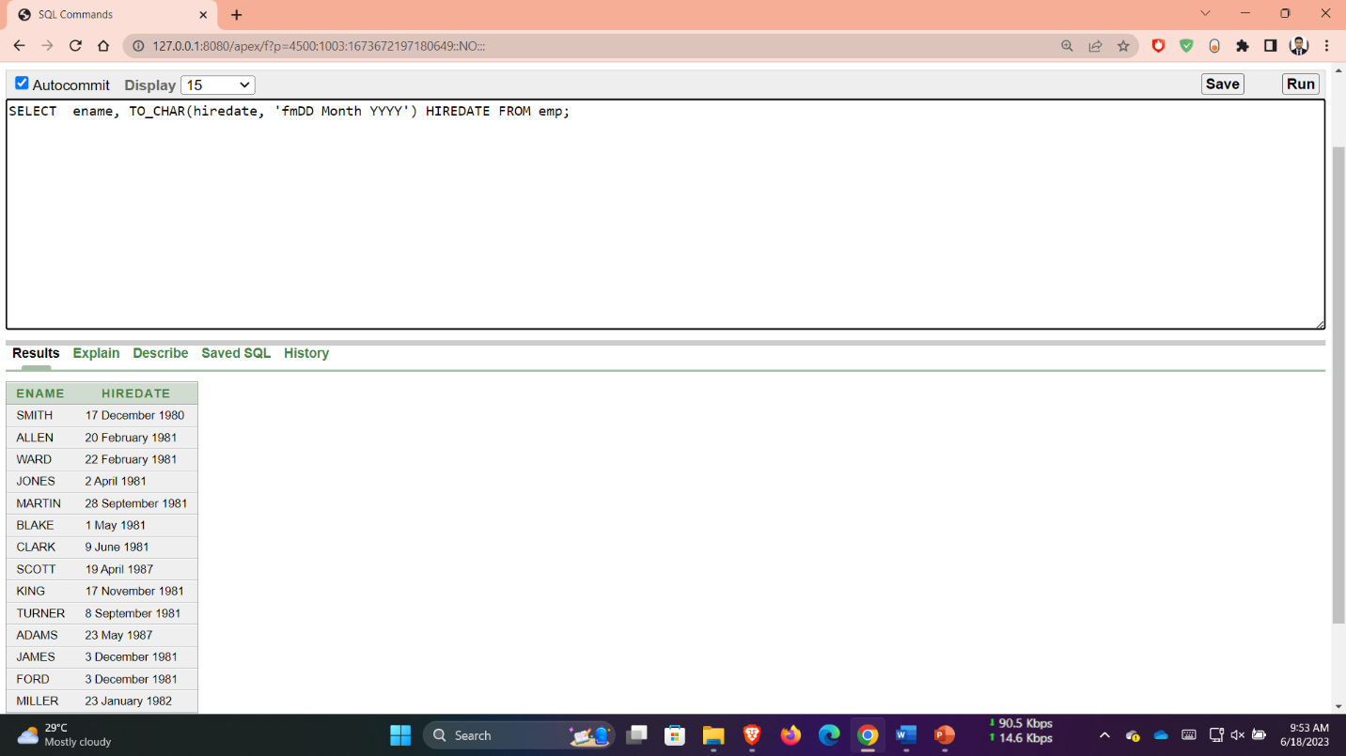

**Q 9**: SELECT TO_CHAR(sal,'$99,999') SALARY FROM emp WHERE ename = 'SCOTT';

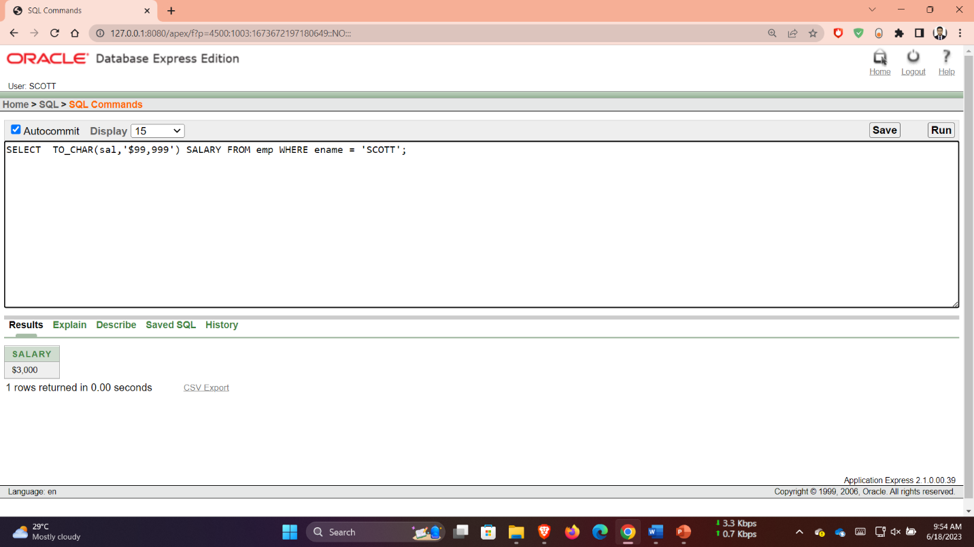

**Q 10**: SELECT ename, sal, comm, (sal*12)+NVL(comm,0) FROM emp;

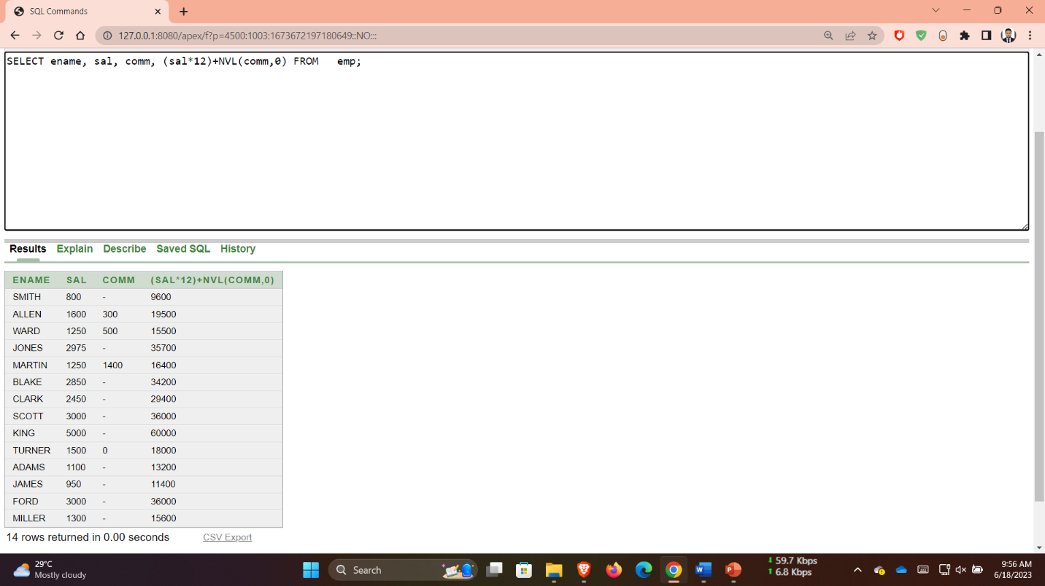

**Q 11**: SELECT job, sal, DECODE(job, 'ANALYST', SAL*1.1, 'CLERK', SAL*1.15, 'MANAGER', SAL*1.20, SAL) REVISED_SALARY FROM emp;

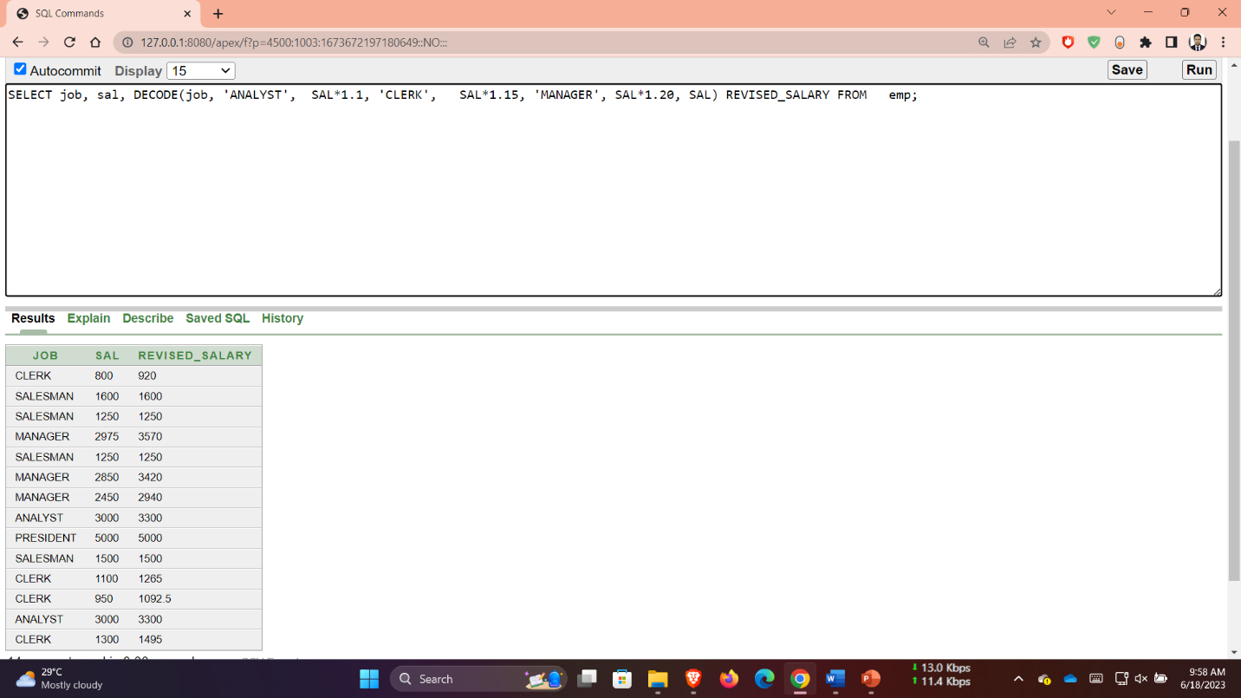

**Q 12**: SELECT ename, NVL(TO_CHAR(mgr),'No Manager') FROM emp WHERE mgr IS NULL;

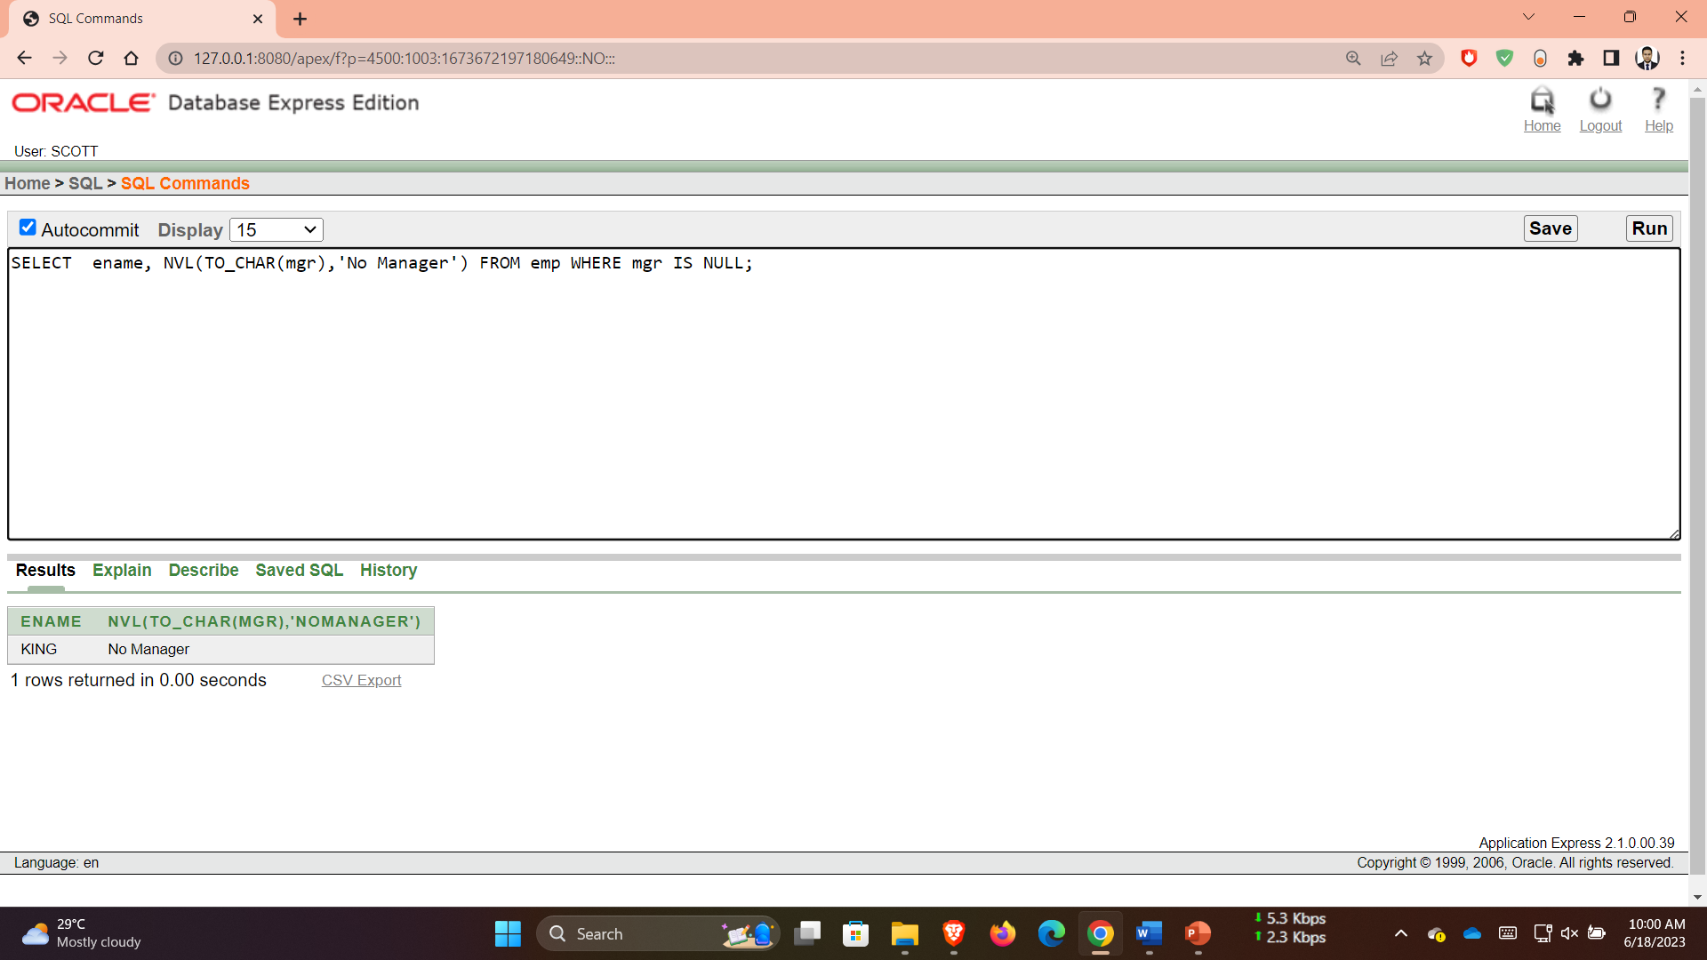

Q 1: SELECT AVG(sal), MAX(sal), MIN(sal), SUM(sal) FROM emp WHERE job LIKE 'SALES%';

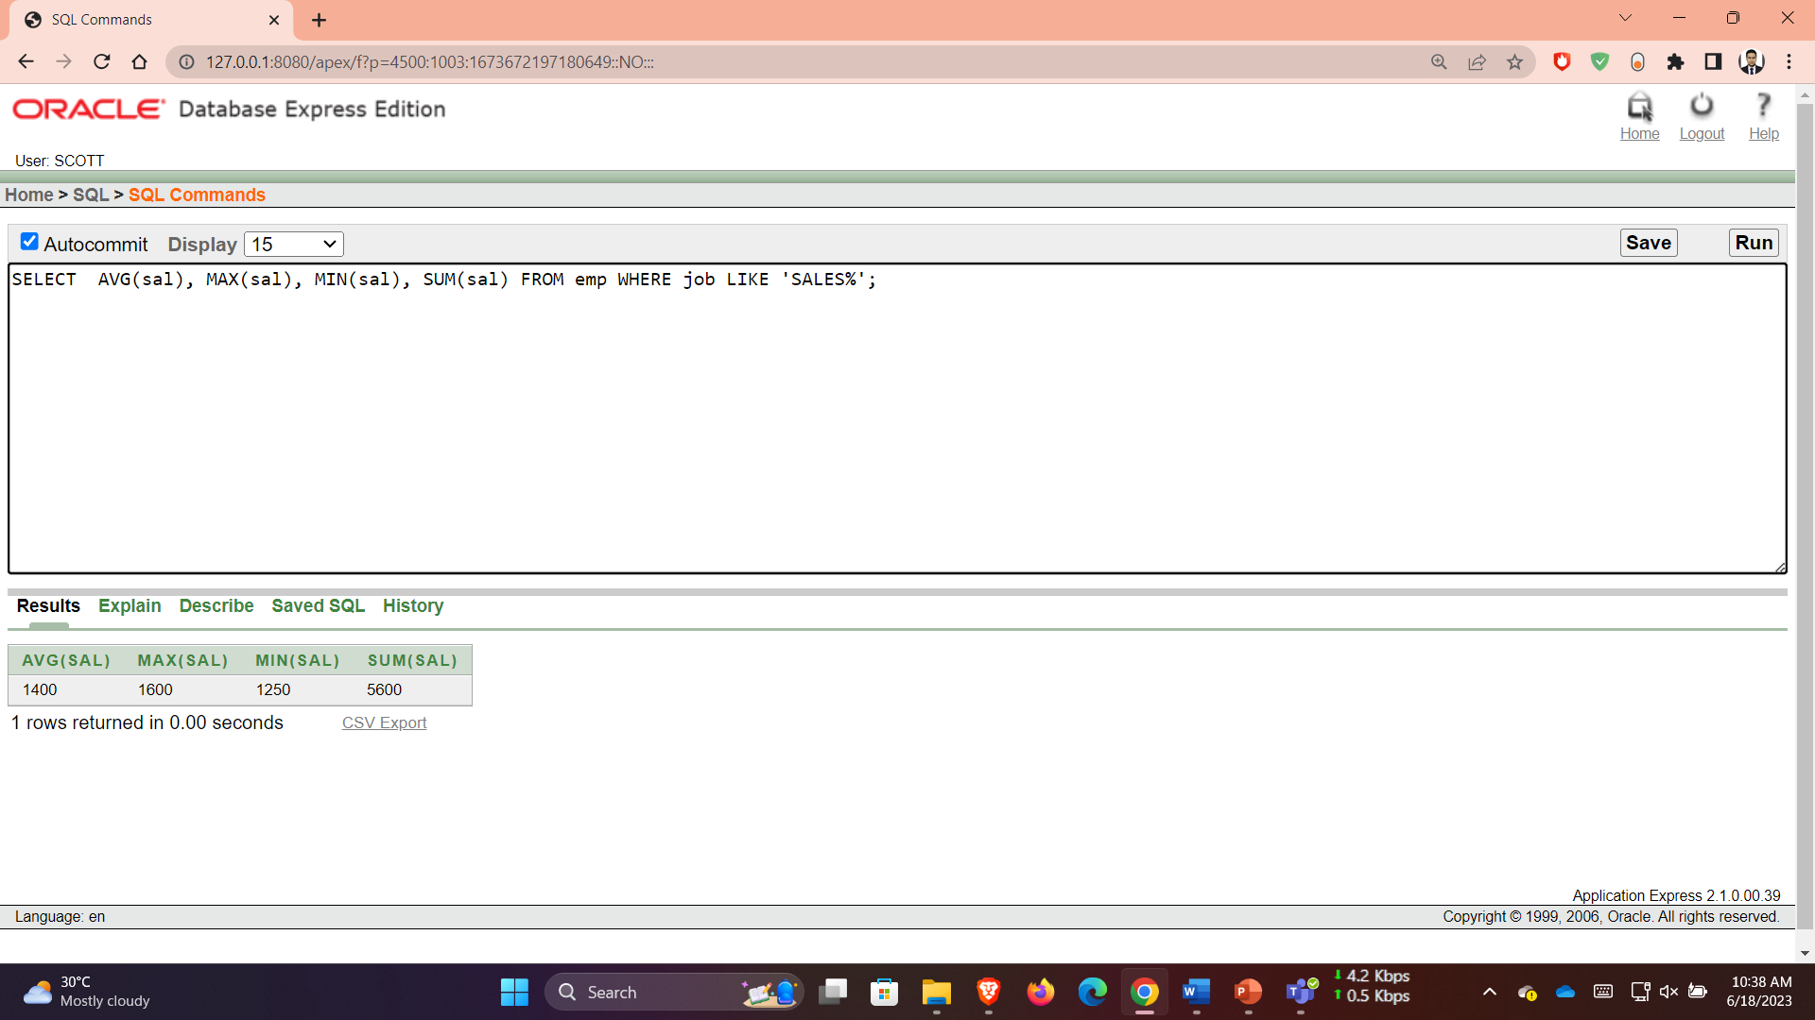

Q 2: SELECT MIN(hiredate), MAX(hiredate) FROM emp;

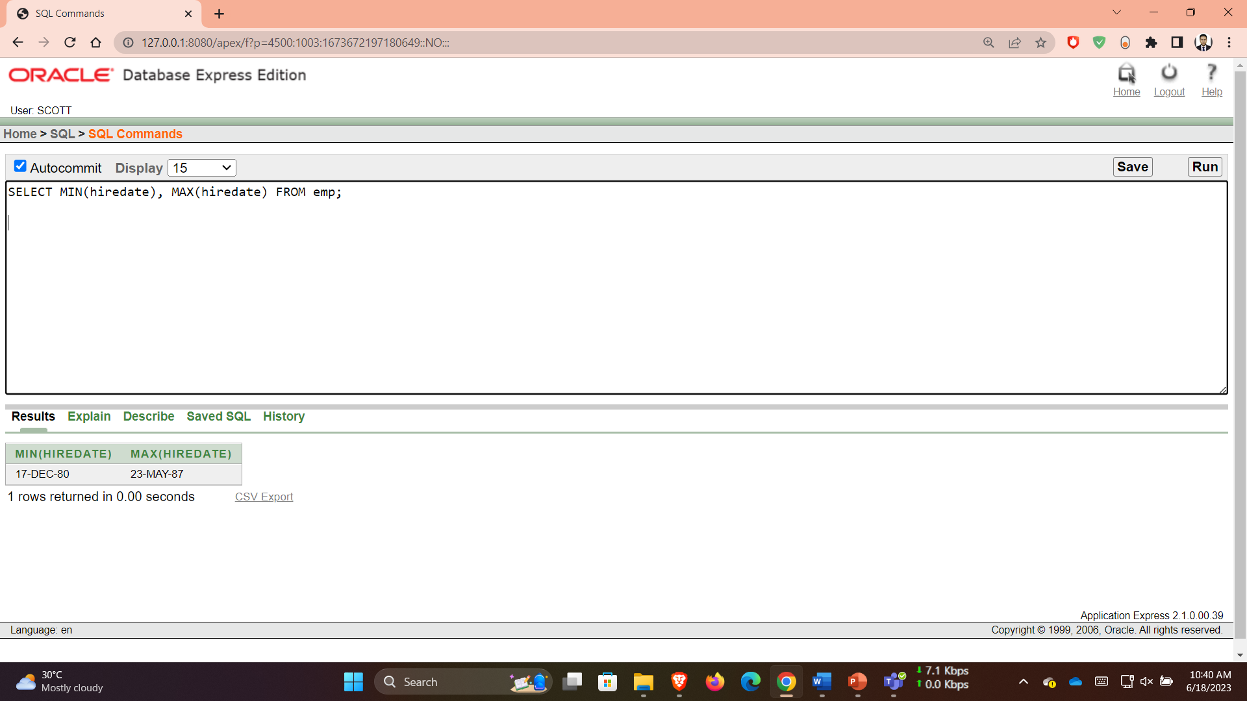

Q 3: SELECT COUNT(*) FROM emp WHERE deptno = 30;

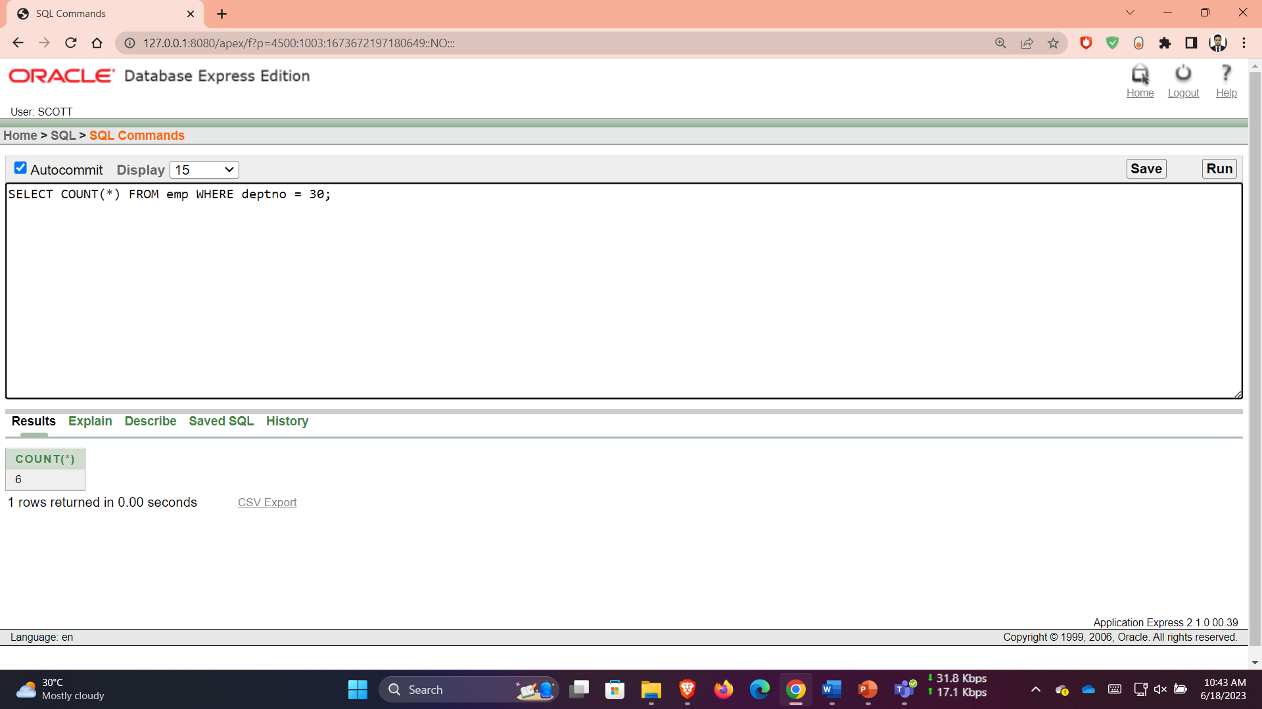

Q 4: SELECT COUNT(comm) FROM emp WHERE deptno = 30;

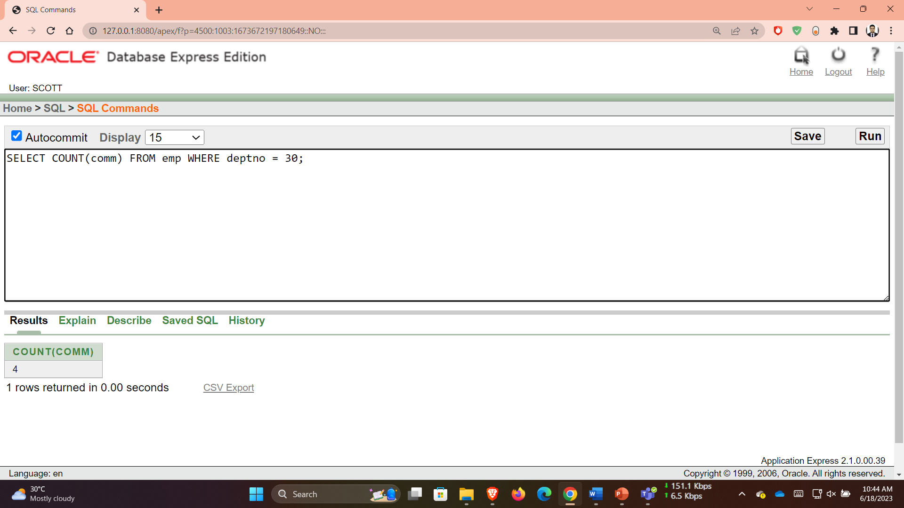

Q 5: SELECT AVG(comm) FROM emp;

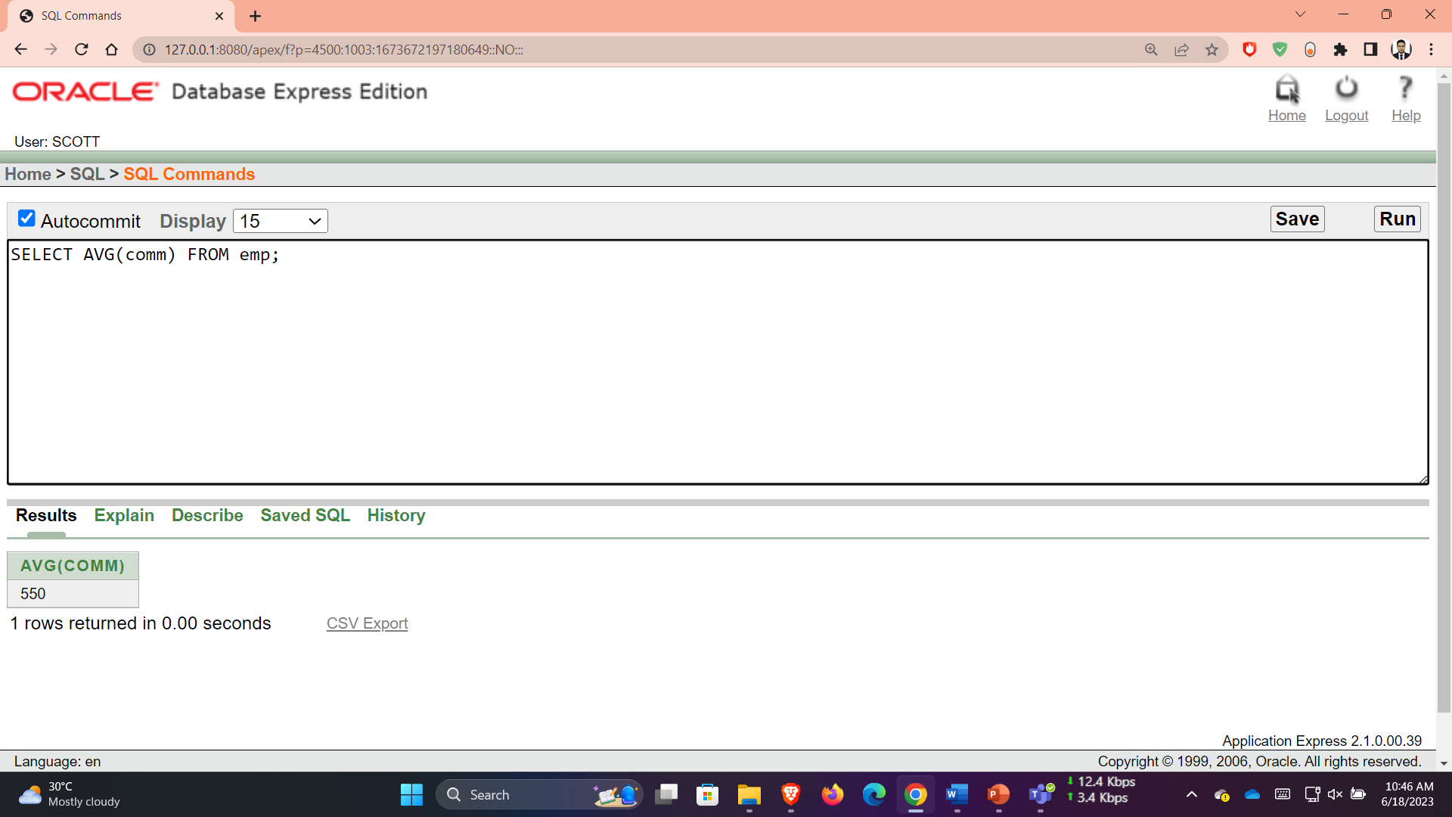

Q 6: SELECT AVG(NVL(comm,0)) FROM emp;

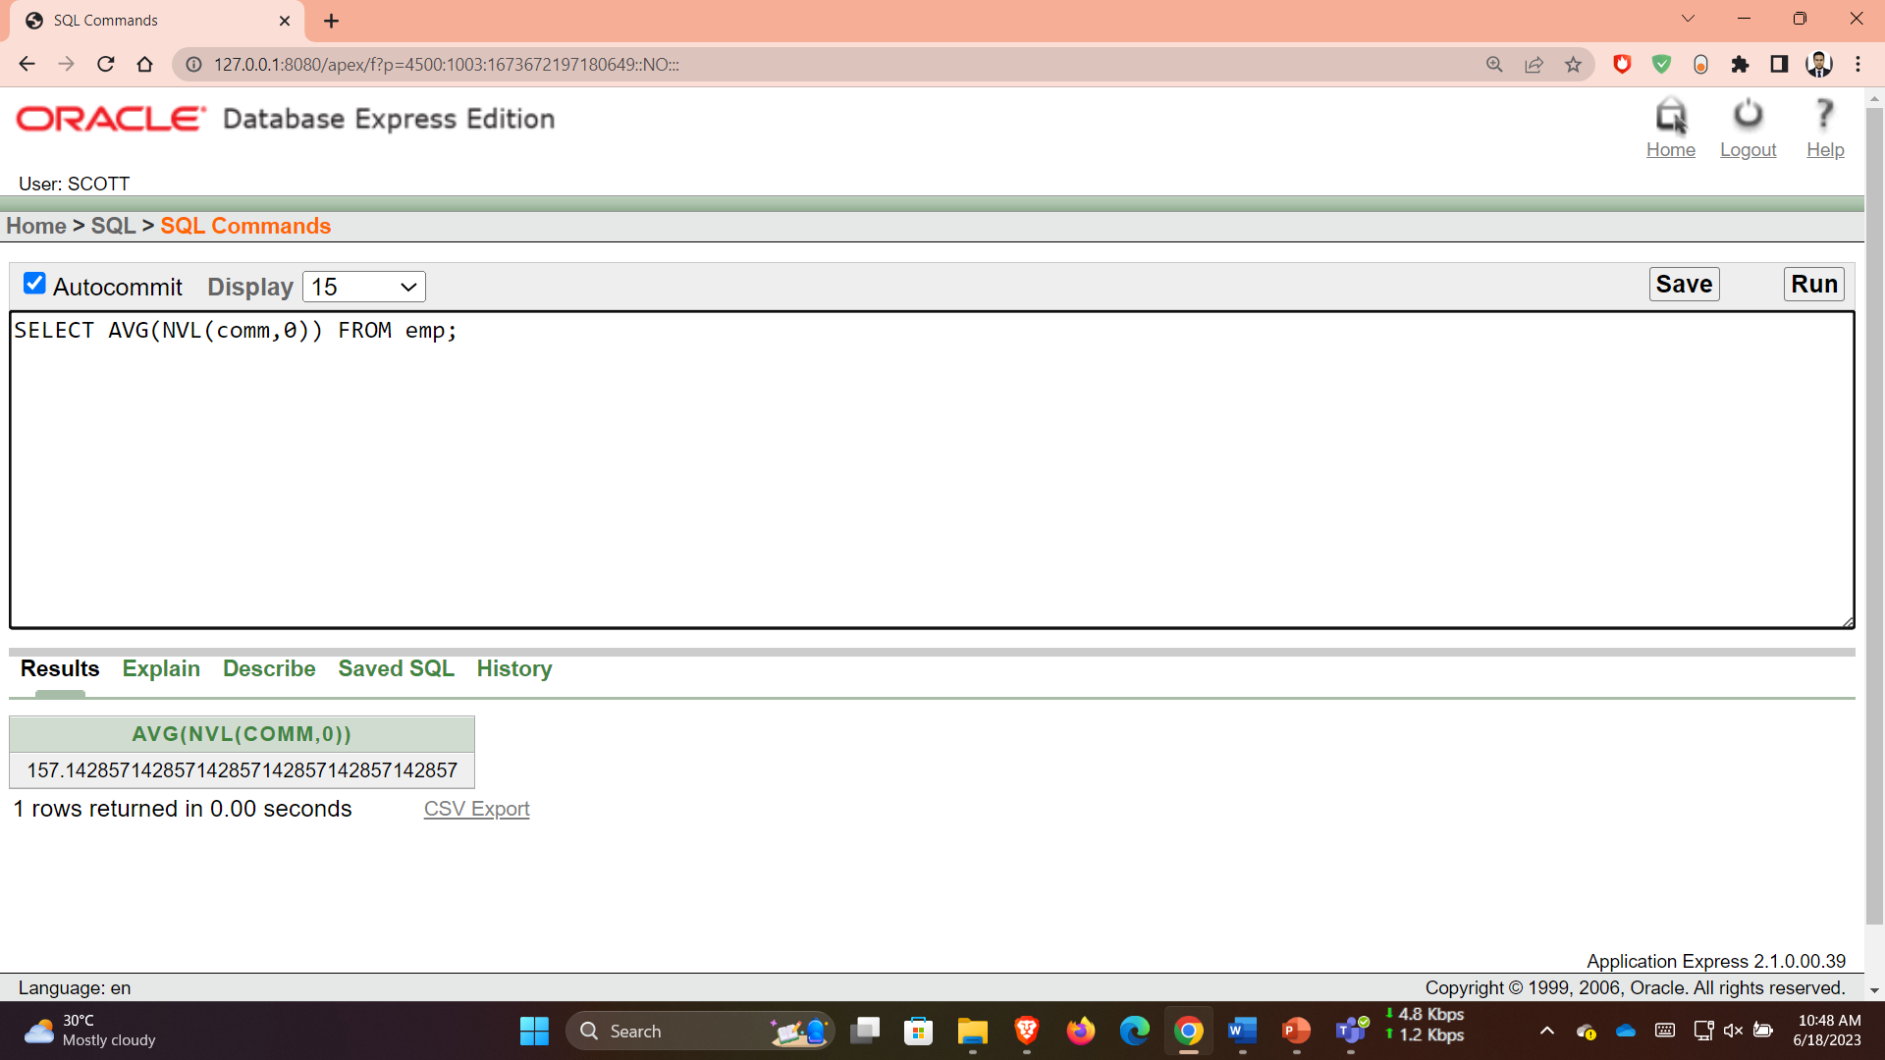

Q 7: SELECT deptno, AVG(sal) FROM emp GROUP BY deptno;

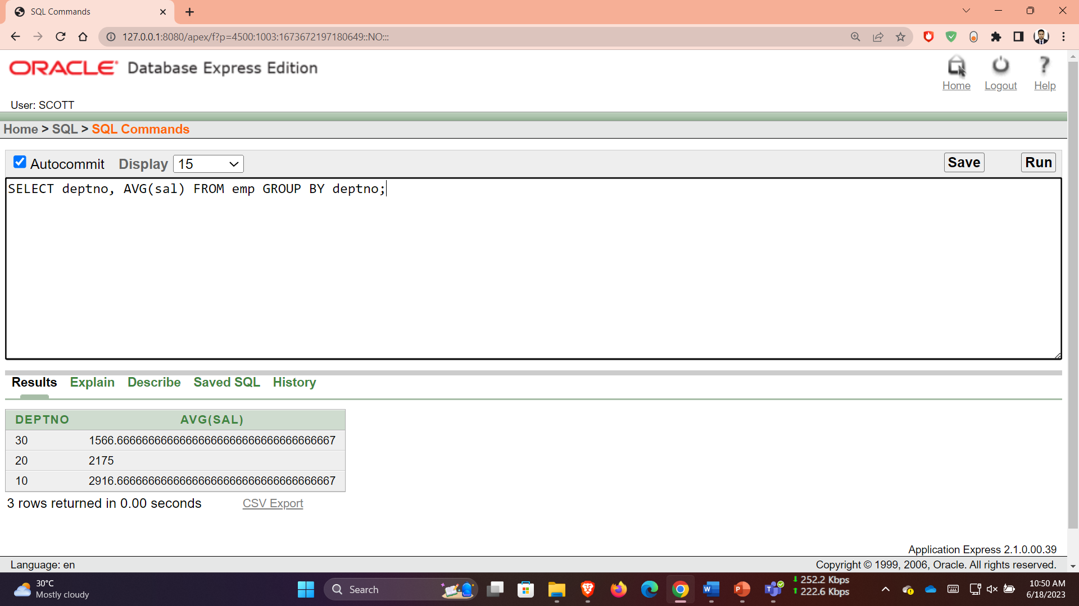

Q 8: SELECT AVG(sal) FROM emp GROUP BY deptno;

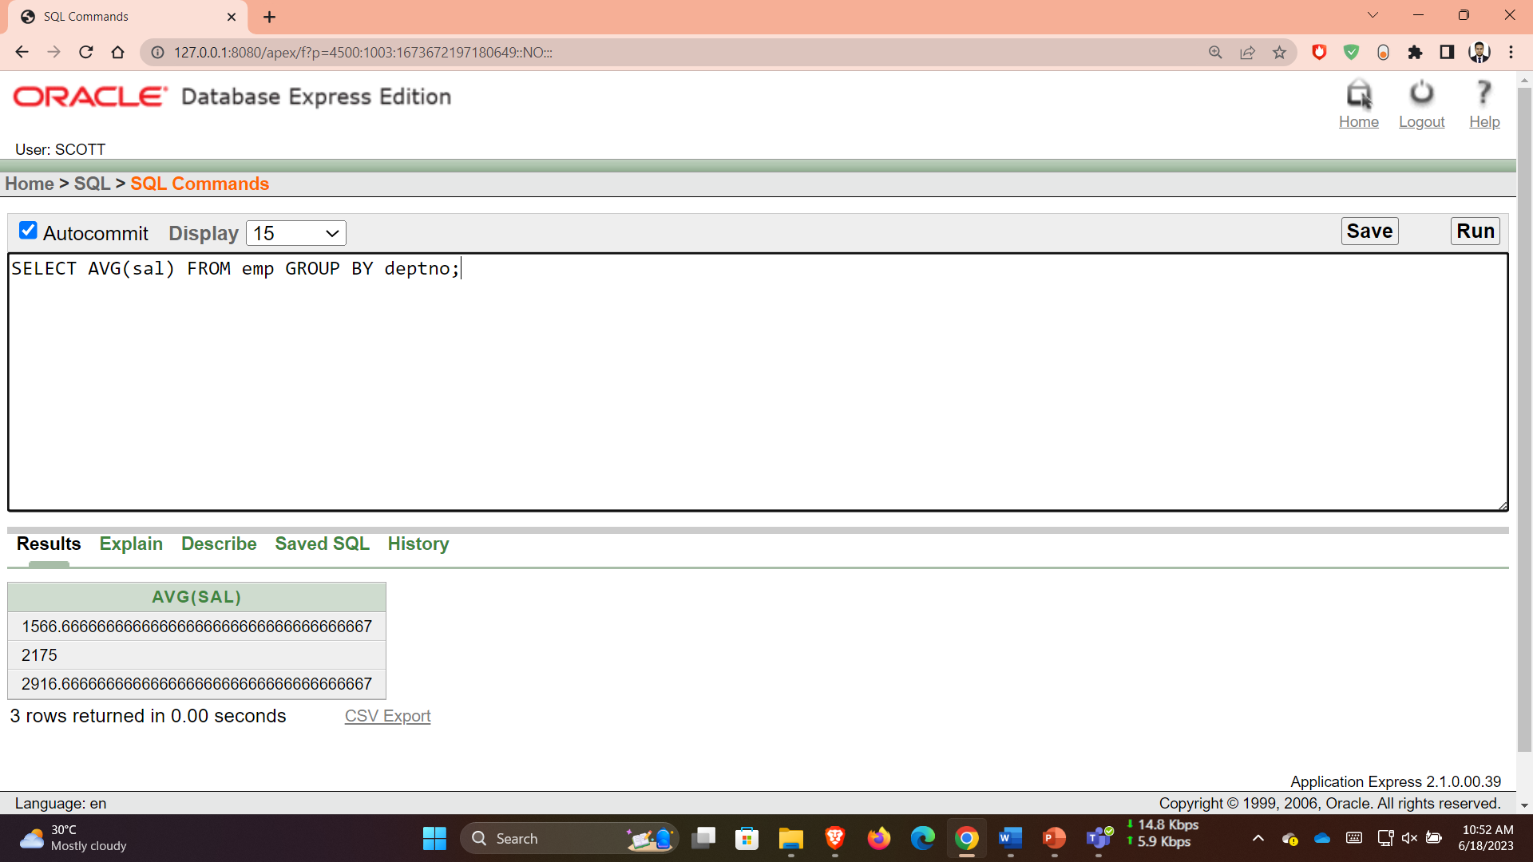

Q 9: SELECT deptno, job, sum(sal) FROM emp GROUP BY deptno, job;

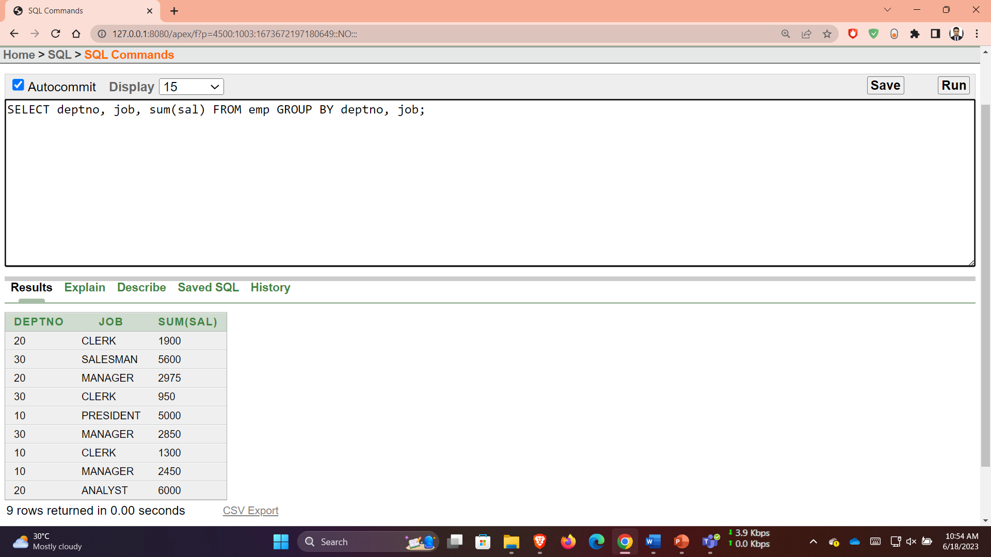

**Q 10**: SELECT deptno, max(sal) FROM emp GROUP BY deptno HAVING max(sal)>2900;

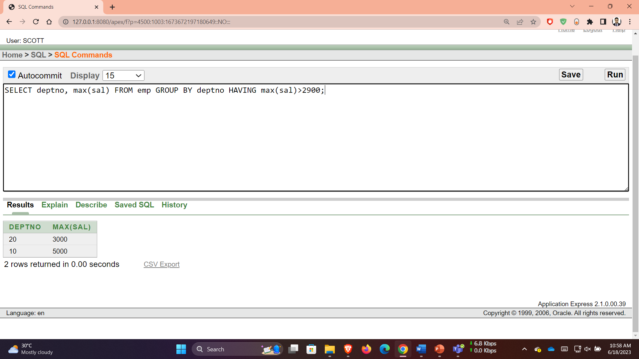

**Q 11**: SELECT job, SUM(sal) PAYROLL FROM emp WHERE job NOT LIKE 'SALES%' GROUP BY job HAVING SUM(sal)>5000 ORDER BY SUM(sal);

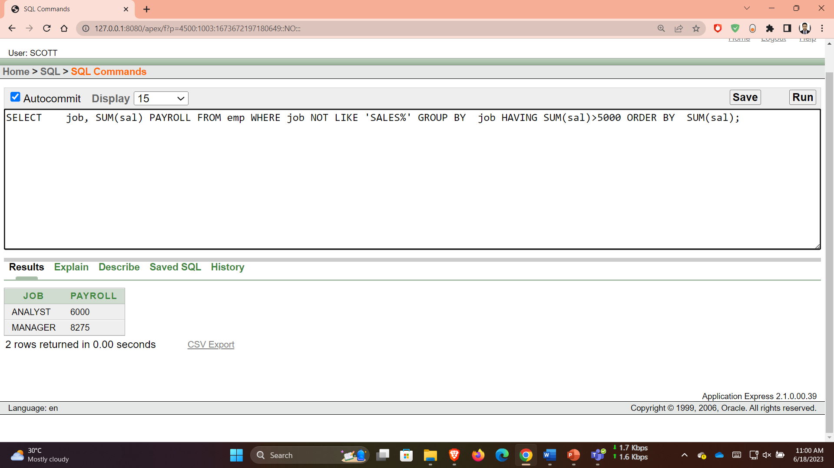

**Q 12**: SELECT max(avg(sal)) FROM emp GROUP BY deptno;

